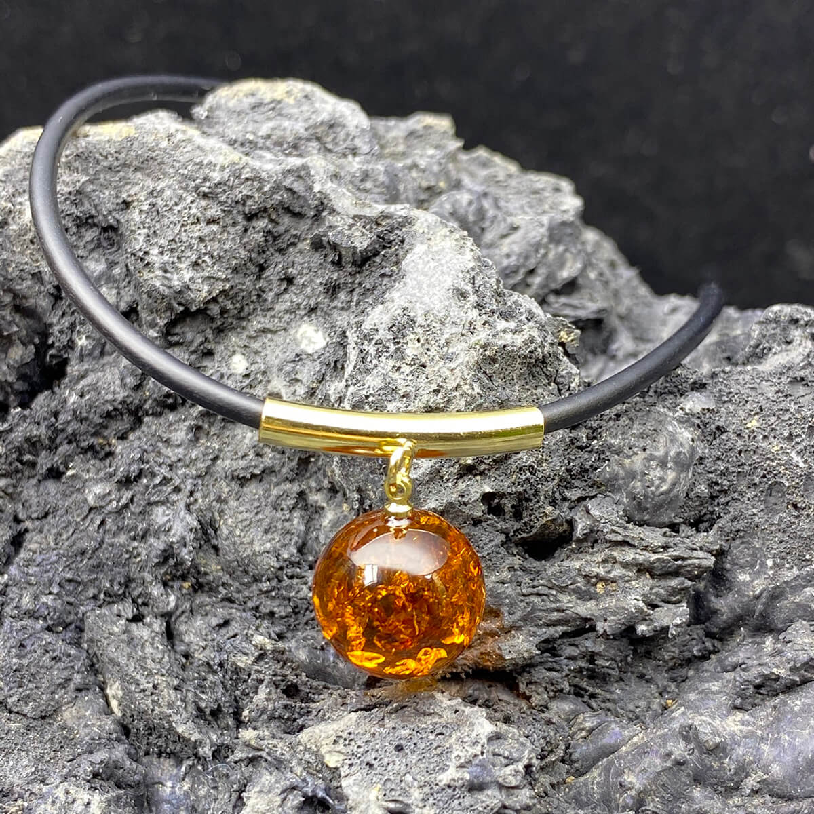**+ First impression of color:**

**The first point to attract buyers must be reminded of the bright red outside, just like the serum color in the product name - it's subtle, luxurious, extremely standard with everyone.**

**+ Luxurious, noble and powerful appearance:**

**This is feel only when the people try that on the range of the Baltic has been. In feng shui, when this stone bracelet will help the user feel a kind of power and is the power to protect you against difficulties in this life.**

**+ Effects of Baltic blood amber chain on users:**

**Confronting young children: according to the most recent studies from scientists, the Baltic blood amber chain has an effect on the health of the user. Accordingly, we have a special effect on young children. By because in amber has many substances that are good for pain relief, as well as stimulating growth.**

**For adults: For adults, the Baltic amber feng shui stone ring has the effect of avoiding the wind as well as the stone rings that help limit the bad effects of the external environment on the user's health.**

**Material: Amber.**

**Audience: Both men and women.**

**Origin: Poland.**